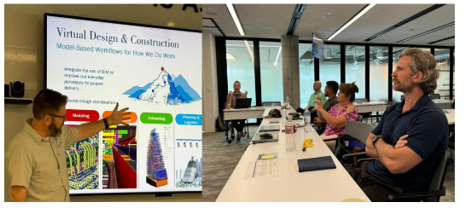

**What can an industry resident do for the construction industry and its partners in education?**

While participating in a Robert L. Bowen Industry Residency, educators spend several weeks on site of a construction project with the intent of gaining field experience to bring back to their classrooms. The program is truly an investment in the future of the construction industry, providing educators with valuable hands on experience that can be shared with their students. An industry residency opens the door for construction partners, educators and universities to actively support and be engaged in educational activities that benefit all segments of the construction industry. Educators are supported equally by the AGC Education and Research Foundation, their host AGC member company and their institution.

[APPLICATION DEADLINE](https://app.smarterselect.com/programs/91306-Agc-Education-And-Research-Foundation): DECEMBER 1, 2025

*AGC Education & Research Foundation*

*2300 Wilson Boulevard, Suite 300 Arlington, VA 22201*

*Paige Packard*

Email: paige.packard@agc.org

Phone: (703) 837-5387

[www.agcfoundation.org](http://www.agcfoundation.org)

Frequently Asked Questions about Industry Residency

**Q**. Why do faculty want to participate in an industry residency?

**A**. It is the best way for construction education faculty to gain valuable and current industry experience

that they can share with their students and fellow faculty members, both within and outside of their

home institution.

**Q**. How will an industry residency benefit the construction industry?

**A**. Hosting an industry resident is an investment in the future of the construction industry. Faculty who

are knowledgeable about contemporary issues and state‐of‐the-art management techniques are best

equipped to ensure that students graduating from construction education programs are well prepared to join the industry. Through relationships with industry residents, constructor hosts also gain information

about best practices and leading edge methods and technology that faculty have studied through their industry collaborations and research activities.

**Q**. Can I expect an industry resident to work regular hours? Will he or she have other commitments

that will interfere with the work at my company?

1. Industry residents are expected to make a commitment to their host company. They will work within

an agreed-upon schedule and produce timely, key deliverables. Each industry resident will be evaluated

at its conclusion to ensure a quality experience has been achieved by the faculty member, the industry

host, and the university.

**Q**. What am I responsible for as a constructor host?

**A**. The constructor host is expected to participate in the planning of the industry residency; work as a collaborative partner to define the scope of the residency; provide constructive feedback when needed during the residency; and assess the overall experience at its conclusion.

**Q**. What if the industry resident has access to proprietary information? Is that going to be published somewhere?

**A**. Part of the planning process for the residency is to ensure that all parties are aware of and respect

the need for confidentiality of proprietary information. No information will be published or released

without the permission of the constructor host.

**Q**. What is the cost?

**A**. The cost model is a partnership in which all parties have “skin in the game.” Traditionally, industry residencies have been a three‐way partnership between the host university, the host constructor, and

the Foundation, though other funding models may be explored.

**Q**. Where can I get more information?

**A**. Contact Paige Packard, Program Director, AGC Education & Research Foundation,

Paige.packard@agc.org.