SOCIAL MEDIA MESSAGES: Targeting Excavators this National Safe Digging Month
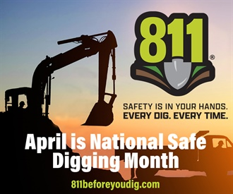
MESSAGE 1: Did you know that more than 70% of damages to buried utilities are caused by professional excavators? And that not notifying 811 is the #1 reason for underground utility dig-ins? This National Safe Digging Month, commit to using #811beforeyoudig for #everydig, #everytime to keep yourself and your community safe.

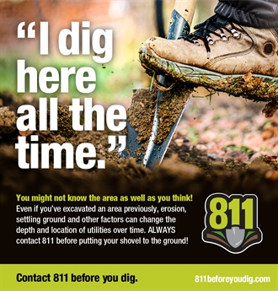
MESSAGE 2: Never assume that you know where buried utilities are located because you’ve worked the jobsite before. Weather, erosion and construction can affect the perceived location of facilities. #811beforeyoudig #everydigeverytime

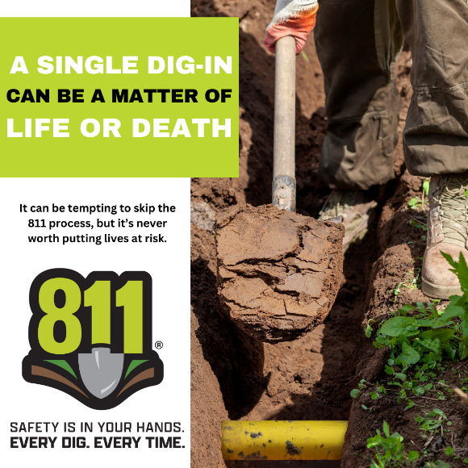
MESSAGE 3: Three digits can save a life: 8-1-1. It is never worth the risk to dig before notifying 811 and waiting a few days for utilities to be marked before breaking ground. #811beforeyoudig #everydigeverytime

