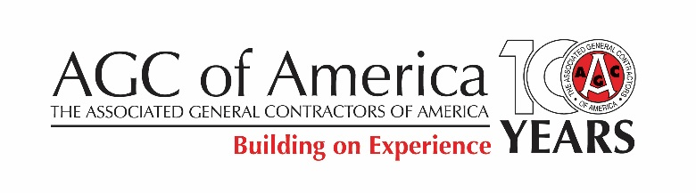

Call for Presentations for:
AGC’s Construction HR and Training Professionals Conference

The Associated General Contractors of America will hold its Construction HR and Training Professionals Conference and Federal Construction HR Workshop Oct. 10-12, 2018, at the Worthington Renaissance Fort Worth Hotel in Fort Worth, TX. This notice is a call for presentations for a limited number of speaking opportunities.

For HR and Training professionals at all levels working directly for construction contractors or AGC chapters, the conference offers an opportunity to share best practices and learn from experts about the most significant, practical, and current HR and training topics in the construction industry. Common job titles of past attendees include:

- HR
- Human resource directors, managers, generalists and administrators
- Benefits managers, administrators and specialists
- Compliance officers
- Employment managers and recruiters

- Training/Workforce Development
- Training and development directors and managers
- Employee development vice presidents and directors
- Apprenticeship directors
- Workforce development and outreach directors and coordinators

Educational sessions:
There are two types of sessions – plenary and breakout.

Plenary Sessions - should be of a general enough nature that they will appeal to either HR professionals, Training/Workforce development professionals, or both groups and should contain enough content for 60-90 minutes.

Breakout Sessions - may be of a more focused nature for either or both groups and contain enough content for 45-60 minutes.

Additional criteria for both breakout and plenary sessions:
- May utilize a single presenter, multiple presenters or a panel format. If a panel method is selected, the panel should consist of 3-4 participants, including a moderator.
- Should share case studies from the commercial construction industry.
- Should employ experience-based learning with interactions, hands-on activities and demonstrations.
- Should present innovative techniques or best practices to a content area listed above.
- Should provide a handout and/or other meaningful takeaway for attendees.

Proposal information

We invite proposals for compelling educational sessions. The driving criteria for proposal selection include:
- Demonstrated innovation in training & delivery, and/or leadership development;
- Engaging and can hold audience attention (sessions that require audience engagement and participation are highly desired);
- Construction industry knowledge and/or experience (sessions that are led or co-presented by construction contractor employees are highly desired); and
- Thoughtfulness and creativity.

AGC expectations
AGC expects all speakers to:
- Sign the AGC speaker agreement that outlines the speaker’s roles and responsibilities.
- Deliver content as developed and agreed upon.
- Submit all program materials, including handouts and PowerPoint slides, electronically by Sept. 1, 2018.
- Grant AGC the right to distribute conference materials to attendees.

Speaker expenses
Selected speakers will receive one complimentary, nontransferable conference registration. Speakers will not be reimbursed for any expenses incurred in developing content or materials for their presentations, travel to/from the conference, or accommodations.

Submission instructions
Your completed presentation proposal form, which can be found at www.agc.org/TrainingHRProposal, should be submitted by close of business on Thursday, March 1, 2018.

Those who submit a presentation will be notified by April 2, 2018 whether their presentation was accepted.

Questions
For questions, please contact Crystal Yates at yatesc@agc.org or 703-837-5437.

