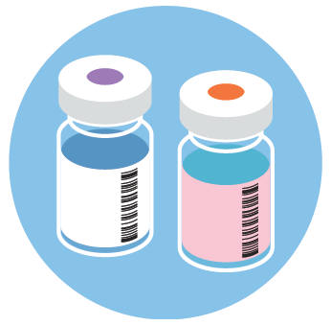  VACCINES  Vaccines work with your body’s natural defenses so your body will be able to fight the virus, if you are exposed. This is called immunity.  WEAR YOUR MASK  When you get the vaccine, you AND your healthcare worker will both need to wear masks.  AFTER YOU GET YOUR VACCINE  - Wear a mask that covers your mouth and nose  - Wash your hands often  - Stay at least 6 feet away from other people you do not live with  Right now, it is not certain how long the vaccine will protect you, so it’s still important to protect yourself and others. | Facts about COVID-19 Vaccines  Source: https://www.cdc.gov/coronavirus/2019-ncov/vaccines/expect.html  the vaccines are safe  - All COVID-19 vaccines being used have gone thorough safety tests and meet the same standards as any other vaccines.  - The vaccines are effective at keeping you from getting COVID-19.  - The vaccines may also keep you from getting seriously ill if you do get COVID.  - You cannot get COVID-19 from the vaccines.  DIFFERENT TYPES OF COVID-19 VACCINES AVAILABLE  - Most COVID-19 vaccines are given in two shots  - The first shot gets your body ready  - The second shot is given at least three weeks later to make sure you have full protection  - If you are told you need two shots, get both.  - The vaccines may work in slightly different ways, but all types of the vaccines will help protect you.  SIDE EFFECTS  - The vaccines may cause side effects – like sore muscles, feeling tired, or mild fever – in some people.  - For most people, these side effects will last for only a day or two.  - Having these types of side effects does NOT mean that you have COVID-19.  - If you have questions about your health after your shot(s), call your doctor, nurse, or clinic.  - While it is unlikely that you will develop a serious reaction, such as not being able to breathe, if it does happen, call 911 or go to the nearest emergency room.

