
Hotel and Travel Information Page
2016 AASHTO Meeting
The Ritz-Carlton, Amelia Island, FL
September 7-11, 2016
Hotel Information
The Ritz-Carlton, Amelia Island
4750 Amelia Island Parkway
Amelia Island, FL 32034
Phone: (904)-277-1100
Fax: (904-491-1567
Website: http://www.ritzcarlton.com/en/hotels/florida/amelia-island

Hotel Overview

Experience an unforgettable beach getaway at the Ritz-Carlton, Amelia Island. This North Florida luxury resort is located in a peaceful setting, a perfect place for people to reconnect. Enjoy a relaxing day, head to one of Florida’s luxury on-site spas. Experience a traditional mind and body comforting massage in a hammock. This Northern Florida resort is perfect for nature lovers and those who thrive on sun, sand and outdoor activities. Prepare your scenes for a cutlery experience like no other, enjoy a signature southern inspired coaster cuisine or indulge in signature burgers and local beer in a laid-back sports bar atmosphere. This resorts location offers an abundance of things to discover, including a variety of interesting shops and museums to browse along in the heart of historic Fernandina Beach, Florida.

Group Rate: $269 + tax
Cut Off Date: Wednesday, August 3, 2016
Check In: 4:00 PM
Check Out: 11:00 AM
Cancellation: AGCA agrees to notify resort, in writing, within 5 business days of any decision to cancel.

Click here or call the hotel at (888) 239-1217 and mention Associated General Contractors of America 2016 September Meeting to receive the group rate.
Travel Information
Airport
Amelia Island is an easy 30-minute drive from Jacksonville International Airport (JAX)

Airport Shuttle
Shuttle transportation to and from airport and hotel for a fee of $85 + gratuity set up by hotel concierge.
For more information call (904)-277-1100.

Taxis
A one-way taxi ride between the airport and hotel is approximately $65-$75 to the hotel
Expect the travel time to be about 45 min.
For more information call 904-741-0008

Town car pick up flat Rates: 3 people pick up $83.70
Shuttle 7 & 10 passenger van $50 first person, 15 additional person
For more information call 904-741-4401

Hotel Parking
They offers Valet Parking, $20 per vehicle, per day, plus sales tax.

Hotel Services
Internet
Complimentary in-room internet access for associates.

Health Club
Complimentary Health Club access.

Weather
The average weather in Amelia Island in July is a low of 69 degrees and a high of 86 degrees.

Attire
Wear layers meeting room temperatures can run hot and cold.

WEDNESDAY, SEPTEMBER 7 - Business casual for the meetings. The dress for the evening will be dressy casual attire.
THURSDAY, SEPTEMBER 8- Business casual for the conference.
FRIDAY SEPTEMBER 9 – Business casual during the day. The dress for the evening will be dressy casual.
SATURDAY, SEPTEMBER 10 - Business casual with comfortable shoes.

Conference Manager
Tina Schneider, CMP
Office: 703-887-8306
Cell: 703-887-8306
tina.schneider@agc.org

Safety and Security
Emergency Information and Security Offices
In the case of an emergency contact 911 or 66 our internal hotel emergency phone monitored by hotel. Security offices are located at the employee entrance of the hotel in the back of the house.
For Loss Prevention call 904-277-1011, Staff is trained for CPR and First Aid.

Emergency Area :( 3 evacuation areas)
- OFL-Evacuation are 1
- Pool-Evacuation are 2
- Spa-Evacuation area 3
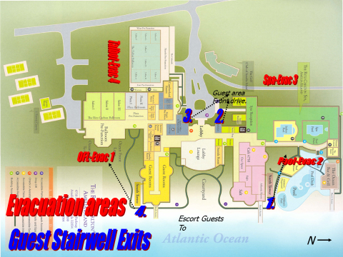

Lost and Found
Contact hotel security in the case of lost and/or stolen items when the registration desk is closed. This is handled by our Loss Prevention Department

Shipping
Shipping Information:
The following information must be included on all packages to ensure proper delivery:
The Ritz-Carlton, Amelia Island
AGC September 2016 AASHTO Meeting
Package Recipient Name:
September 7-11, 2016
Attention: Meetings and Special Events Manager’s Name
4750 Amelia Island Parkway
Amelia Island, FL 32034
To receive packages at the hotel:
Guests are informed during check in if they have a package. The package can be delivered to the meeting space, guest room or picked up at the front desk. Call (904)-277-1100 for additional information.
To mail packages out of the hotel:
Attendees can use UPS or FedEx. They come once a day for all pickups around 12 pm. If attendees do not have preprinted labels, hotel concierge has labels available. Additional charges can be applied to the master account, room or individual.
UPS: Call l 1-800-742-5277 or 1-800-PICK-UPS for any questions.
FED EX: Call 1-800-463-3339 for more information.

