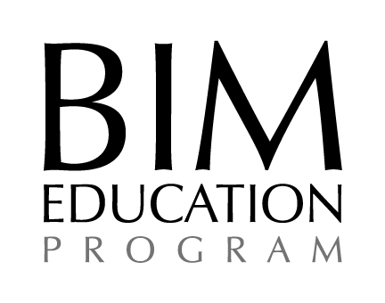

This is to certify that:

[Insert Name]

has successfully completed the unit of AGC’s Building Information Modeling Education Program,
an AGC-sponsored education program entitled:

[Insert full unit title]

This certificate has been awarded in recognition of this effort
and accomplishment in increasing professional ability.

Date

___________________________________ ____________________________________
Program Sponsor Program Instructor

